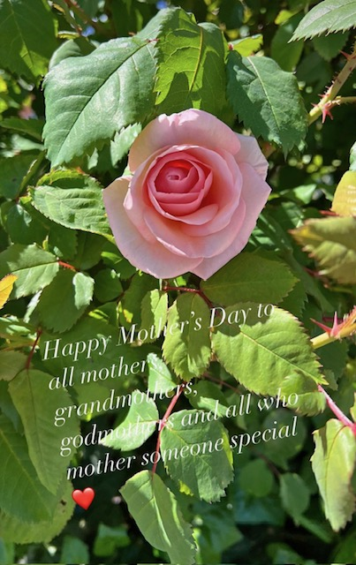

**Bring Mom and she’ll receive a beautiful rose for Mother’s Day!**

**The Village of Williston Park Beautification Committee**



**Invites you to …**   
***“Little Make a Difference Day”***

***Saturday, May 10, 2025***

***9:00 a.m.***

***Village Hall Parking Lot (Rear of 494 Willis Avenue)***

We will provide garbage bags and gloves. Please bring your rakes and shovels.

Groups will be assigned to public areas within the Village and

ask for only a hour or two of your time to help clean up and beautify Williston Park for the Spring.

All school groups, Girls Scouts, Brownies, Boy Scouts, Cub Scouts (accompanied by chaperone)

and residents are invited to join us.

Please call 746-2193 or email Village Hall ([boardsecretary@villageofwillistonpark.org](mailto:board@villageofwillistonpark.org))

for questions, information or to register your group.

***“Together We Will Continue to Make a Difference”***