The Incorporated Village of Williston Park
Christmas Tree Lighting Ceremony

Village Hall
494 Willis Avenue
Sunday, December 3rd
6:30 p.m.

St. Aidan’s Christmas Choir directed by Reagan Stone!

Christmas Carols sung by Scouts and neighbors!

Santa arrives by fire truck!

Hot chocolate and candy canes will be served!

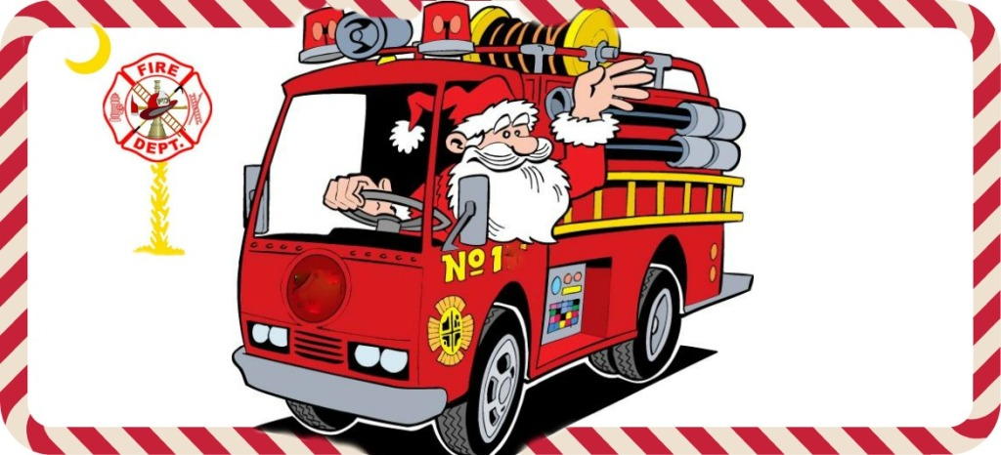

VOLUNTEERS NEEDED FOR OPERATION SANTA
For Sunday, 12/24 Santas and drivers needed!

1-2 hours of your time starting at 5:30 p.m.
Please Contact Village Hall
746-2193

