The Incorporated Village of Williston Park
Christmas Tree Lighting Ceremony

Village Hall
494 Willis Avenue
Sunday, December 4th
6:30 p.m.

Christmas Carols sung by Scouts and neighbors!

Santa arrives by fire truck!

Hot chocolate and candy canes will be served!

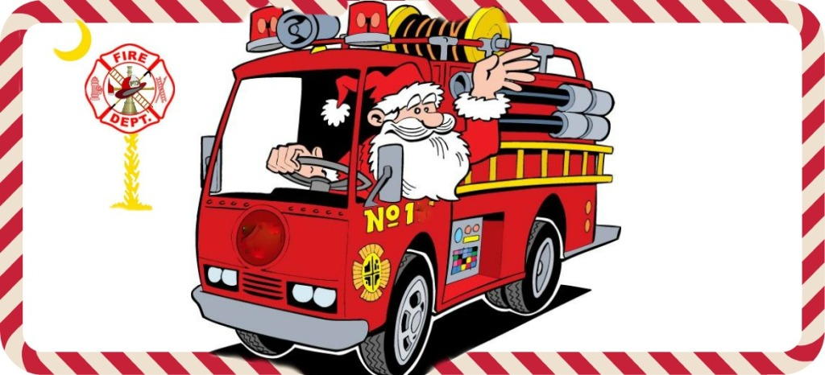

VOLUNTEERS NEEDED FOR OPERATION SANTA
For Saturday 12/24 Santas and drivers needed!

1-2 hours of your time starting at 5:30 p.m.
Please Contact Village Hall
746-2193

