Annual Halloween
Ragamuffin Parade
Sunday, October 31st
6:15 line up, 6:30 step off
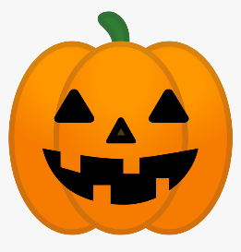
Starting from the American Legion parking lot - All ghosts, goblins, witches and those who want to join the fun can come to the American Legion parking lot at 6:15 p.m., proceed South on Willis Avenue, East on Syracuse Street, South on Broad Street, West on Cornell Street, and South on Willis Avenue ending at the Village Hall.

Pumpkin Carving /Decorating Contest
Carve, paint or decorate a pumpkin. Include a card with your name, age and pumpkin name and put your work of art on the Village Hall lawn starting at 6pm. The Recreation Committee will be awarding gift card prizes for the three best pumpkins! Come by to see the pumpkins and everyone gets a special treat from the Recreation Committee!

Happy decorating!
