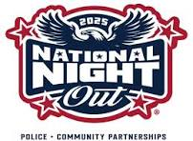

**Tuesday, August 5, 2025**

Come Join us for the Annual

"Children's Parade for a Safer Williston Park"

7:00 pm

Ride your Bicycle, Tricycle, Scooter, Wagon or be pushed in a stroller.



Start at Broad Street and Amherst Street

End at Kelleher Field Picnic Area

***Ice Cream will be served at the finish of the parade***

***Williston Park is a Great Place to Visit, a Better Place to Live***

***Let's Keep it That Way!***

A Police Officer from the 3rd Precinct will be our Guest Speaker