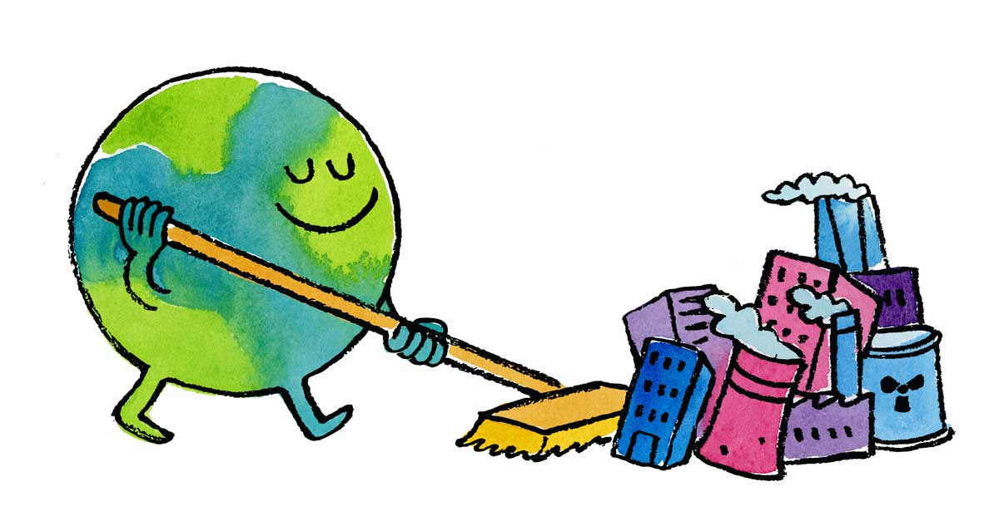

The Village of Williston Park Beautification Committee
Invites you to
Celebrate Earth Day
“Little Make a Difference Day”
Saturday, April 20, 2024
9:00 a.m.

Meet in Village Hall Parking Lot
(Rear of 494 Willis Avenue)

We will provide garbage bags and gloves. Please bring your rakes and shovels.

Groups will be assigned public areas within the Village and
we only ask for an hour or two of your time to help clean up and beautify Williston Park for the Spring.

All school groups, Girls Scouts, Brownies, Boy Scouts, Cub Scouts
(accompanied by chaperone)
and all residents are invited to join us.

Please call 746-2193 or email Village Hall (boardsecretary@villageofwillistonpark.org)
for questions, information or to register your group.
Thank you!

“Together We Will Continue to Make a Difference”

