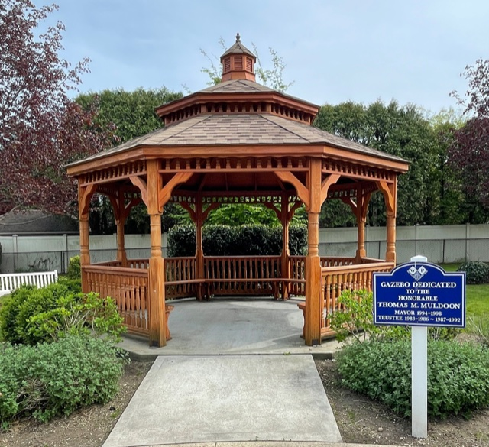
SENIOR GAZEBO CONCERTS
7:00 pm @ Hillside and Liberty Avenue
Free BBQ will be provided at all concerts.

June 19th in Celebration of Flag Day – DJ Steve Griffin

(Please notify the Village Hall if you’ll be celebrating your 50th wedding anniversary in 2025)

July 24th – Gene Benedetto

August 28th – (TBD)

KELLEHER FIELD CONCERTS

Kelleher Field – Syracuse Street & Stratford Avenue

7:30 pm – Bring Chairs and Coolers

June27th – Five Stone Band

July 11th – Acoustic Blue

August 22nd – Hambones

